Just Wood Leicestershire

Ryan
Ryan was 26 years old with previous convictions, and was determined to make a fresh start for himself and his young children. He started volunteering at Just Wood Leicestershire just weeks after being released from prison, initially on a two-week basis, but got so much out of the project he ended up volunteering five days a week and sometimes even Saturdays.
His background in painting, decorating and carpentry allowed him to make a real contribution at the project, producing log stores, benches, and head boards, and he also picked up new skills along the way. The enterprise guided him through obtaining his CSCS card, and on the same day as passing his test his was offered a job at a local building site with Mace Construction.
Ryan stayed in touch even after leaving the project, and they offered support with opening a bank account and taking the first steps in self-employment. When they last heard from him, he was working successfully as a bricklayer.
Ryan says:
“If it hadn't have been for you I would have been back inside. You helped me to keep busy, and gave me some sound advice. Thanks to you, I’m back on my feet again.”

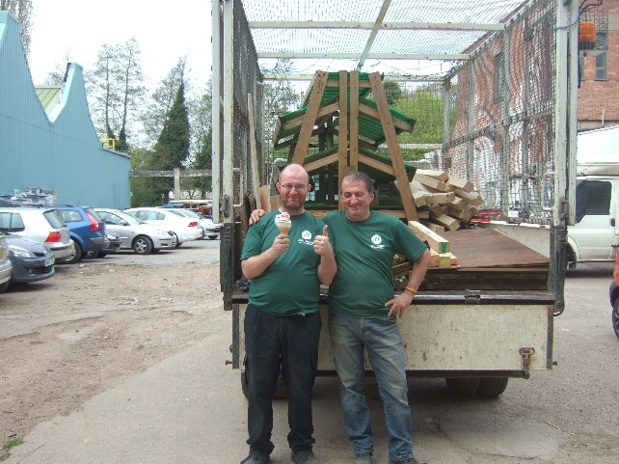
Dave
Dave had been unemployed for several years when he came to Just Wood Leicestershire CIC on a four week work placement in March 2015, through Intraining, a training provider working closely with the Job Centre.
Dave worked at the wood yard breaking down pallets, de-nailing and keeping the wood yard tidy as well as assisting on collections from construction sites. He enjoyed the placement so much he sought permission to stay with the project until he secured paid work. He quickly became an invaluable team member and was spotted by Yummy Foods, a company with premises on the same site, and now works for them as an order packer. Dave says:
“If it hadn’t have been for Just Wood I would have stayed at home and would still have been looking for work. I had the opportunity to do something different and had a reason to get up in the morning.”

Roger
Roger had not been in paid employment for 10 years when he came to Just Wood on a 6 month work placement through Acorn Training in June 2015. Roger drove the truck on collections and deliveries, and at first he lacked confidence in driving and was very quiet. He quickly settled in, gained confidence and enjoyed his placement.
Roger was an invaluable team member and was soon able to undertake the paperwork associated with waste collections, deal with site managers and supervise other volunteers.
In late August Roger was identified as a willing and able worker by the facilities manager at Eddie Stobart, as well as another customer at Widdowson group, and Yummy Foods. In short, Roger was offered 3 jobs in the space of a week.
With our support, Roger chose to undertake the job that was right for him, and he now works with another ex-volunteer, Dave, at Yummy Foods. Just Wood was able to secure Forklift driver training and Food Hygiene training for both Dave and Roger, enabling them to secure their jobs.
Both Dave and Roger still pop across the yard and help us out in their lunch breaks.
Roger says:
“The support and encouragement I received at Just Wood, the way I was treated with respect and as a team member really helped me to renew my confidence and gain new skills which defiantly helped me with choosing the right job for me. I never thought I would have 3 informal job offers in a week when I hadn’t even formally applied!”

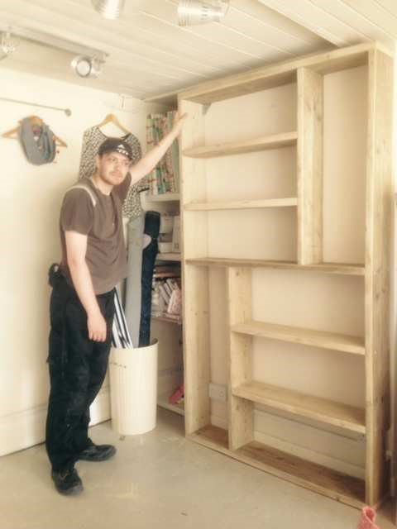
Alan
Alan was unemployed and on work placement, a qualified carpenter but lacking site or factory experience. He had been at Just Wood for 3 months and made several products, as well as visited sites to secure shelving and other items. Just Wood secured him a placement for 2 days a week at a local ‘high end’ door manufacturer, who will provide him with bench joinery experience.
Alan says:
“There is absolutely no way I could have got that placement on my own. Thank you for speaking out on my behalf and getting me a unique opportunity.”

East Midlands Wood Recycling CIC

Jack
Jack was 54 years old when he came to East Midlands Wood Recycling, following a four-year period of caring for his terminally ill wife, her eventual death, and a period of depression during which he could barely leave his house. Although struggling initially, after a few weeks at the enterprise there was a huge change in his appearance and attitude. He was keen to lend a hand, and became a close friend to many of the other volunteers. He left the enterprise in June, and moved across the country, starting a new relationship and securing full-time employment. He sent Kevin (the Managing Director) a card from his new location, saying:
“I want to thank you and Claire for giving me a chance and getting me to believe in myself again… the experience gained in working with you is priceless... I will never forget you and what you have done for me.”

Scott
The special needs school Scott was attending wanted to give him some real-world work experience before sending him off, so they referred him to East Midlands Wood Recycling, where he volunteered once a week making products under supervision. He said that he likes working with us as he has an interest in the environment, and enjoys working with wood.
Enterprise Manager Kevin Ellis says:
“The bird box he made now has pride of place on a tree on the drive up to the school, and he loves telling everyone about it!”

